**Air Pollution App Case Study**

|  |  |  |  |
| --- | --- | --- | --- |
| 1 | **Name of the Project** | **Air Pollution App** | |
| 2 | **Objective/ Vision** | Build a system to keep track of Air Quality.  Application needs to access the data from Database for specific cities which are present in specific states and countries | |
| 3 | **Users of the System** | All Internet users | |
| 4 | **Functional Requirements** | 1)User Should be able to search  2) Air Pollution Search:  1) Search details of average pollution of country  2)Search average pollution of specific state  3)Search pollution of cities | |
| 6 | **Tools and Technologies to be used** | | 1. VCS : Gitlab 2. Middleware : Spring 3. Data Store : MongoDB 4. Testing : Junit, Mockito |

**Title: Air Pollution System**

**1. Synopsis:**

Air Pollution System allows users to get details of the pollution of their city, state and country. Every year, across every border on this planet, air pollution causes more than 7 million premature deaths. The magnitude of the problem should inspire sweeping change, but it doesn’t.

Why? Because like new insights about our climate, the numbers are quick to cause anguish, but get quickly buried by the immediacy of daily life. Every new pollution peak causes new outrage, promptly extinguished into inaction as the news cycle rolls ahead. We care and hope for change, but feel ill-equipped to face a challenge too complex, bigger than us, like it should be a problem for another person or another time.

We see an information problem. We see that with the right information at the right time, wisdom can take over panic. And when wisdom has the upper hand, the urgency of the problem can be channeled into imagining solutions rather than endings.

Previously they had to be depend on the news television channels for the pollution information. Now user can easily find the details of current pollution details as per there requirement.

User can register to portal and easily access the pollution data. User needs to login and he gets option to check the details for pollution. He can check the details of the Air pollution of his/her specific city or will be able to check the Air pollution of specific state or will also be able to get details of Air Pollution of a specific country.

**Software Requirements: JDK 11, Git , Mongo DB, Junit 5 & Mockito, Eureka,**

**Spring Tool Suite, Postman.**

**Minimum Hardware Requirements:**

**CPU: 4GB**

**HDD: 10GB**

**Display Resolution: 1024*800**

**2. Microservies:**

1. LoginAuth

2. AdminService

3. Pollution Service

4. Eureka

5.Api Gateway

**3.Features:**

**For User:**

**Search Air Pollution Details:**

User can search and view air pollution details of their city.

They can also get information of specific state or countries pollution.

**For Admin:**

**Login:**

Admin has to login to admin panel for updating details.

**Update Pollution Details:**

Admin can add, update and delete the details of air pollution.

**4.User Stories:**

**Login:**

**User:**

User will able to access the air pollution data after login into

the account. The data of user will be fetched from database.

**Admin for update data:**

Admin will be able to add, update and delete data from air

pollution database

**Search for User:**

When user login into his account he will be able to search

the air pollution details for the specific city, state and country.

The will be retrieve from the database and filter accordingly.

**Air Pollution service database:**

Air Pollution service database contains details of air pollution

of various countries. The data is stored according to cities .

**5. UML Diagrams:**

**1. Use Case Diagram:**

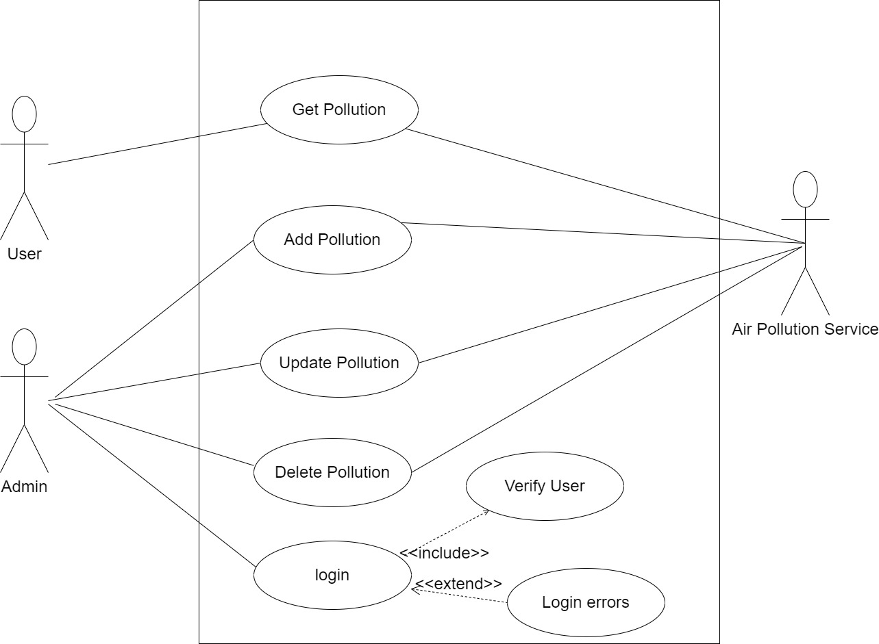

**1.1 Flow Chart Diagram For User**

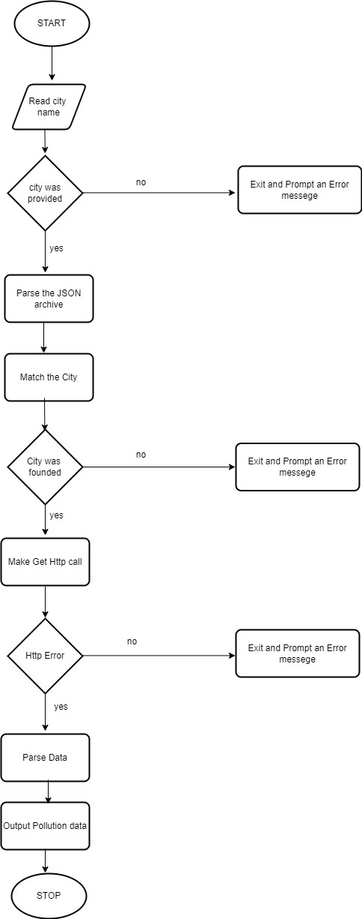

**1.2 Flow Chart Diagram For Admin**

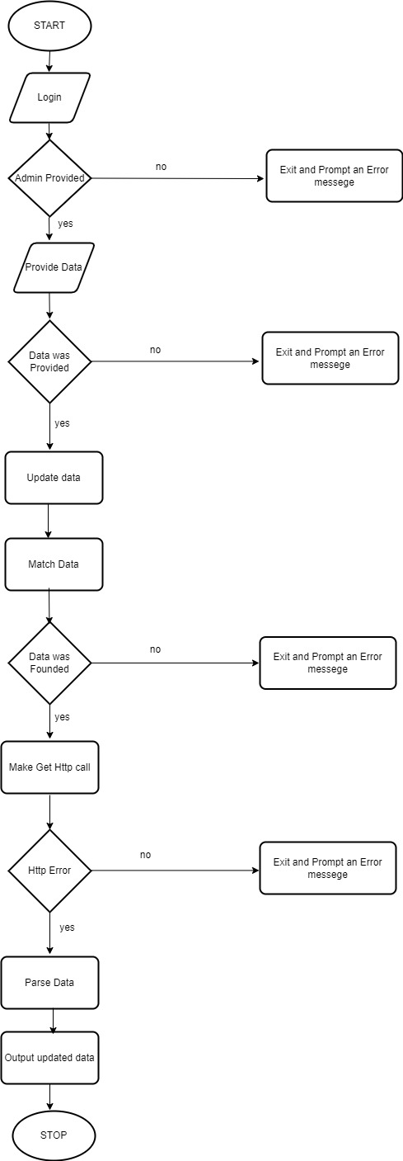

**Conclusion:**

User can search and view air Pollution data according to their needs which helps them in different fields for taking action before any harm is done by pollution